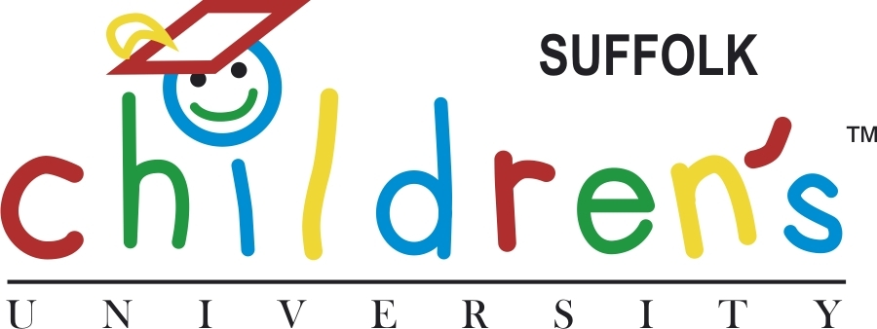

Suffolk Children’s University (SCU) is a county wide scheme supported by Suffolk County Council and is part of the National Children’s University. One of SCU’s aims is to formally recognise, reward and celebrate the commitment that young people (aged 5 -14) make in attending extra curricular activities. These activities can be before school, at lunch time, after school, at weekends and in school holidays.

Thousands of young people across the county are registered with SCU. They are experiencing new and exciting opportunities by taking part in a varied menu of activities, are meeting new friends, gaining self confidence and improving self esteem, all whilst working towards special achievement certificates.

The benefits to young people being part of SCU are:-
- An opportunity to be part of a county wide scheme supported by Suffolk County Council
- Formal recognition of their commitment and involvement in extra curricular activities, with special achievement certificates awarded
- Increased confidence and self esteem as they take part in more varied activities
- Improvement in their health and well being

All SCU activities registered under the scheme are attributed to one of 6 categories: Academic, Active, Creative, Culture, Nature and Service.

- Once a young person has attended an activity, which is part of the SCU, for a total of 5 hours, they will gain a sticker in their SCU Passport and receive an attendance certificate

- BRONZE Special Achievement Certificate.
15 hours (3 activities 5 hours) activity must be 2 different categories, qualifies for Bronze

- SILVER Special Achievement Certificate.
25 hours (5 activities of 5 hours) 2 different categories, qualifies for Silver

- GOLD Special Achievement Certificate.
35 hours (7 activities of 5 hours) 2 different categories, qualifies for Gold

All extra curricular clubs outside of school, such as performing arts, dance and drama, sports, all Uniform Groups (guides, scouts, brownies, cubs etc) can count towards the awards as long as the activity provider is accredited and is a member of SCU.

To find out more information about Suffolk Children’s University and to see which organisations are providing SCU accredited activities visit our website www.suffolk.gov.uk/suffolkcu

If you have any questions or require any further information please contact Jackie Fairweather, SCU Programme Manager at scu@cyp.suffolkcc.gov.uk

